**ASSIGNMENT NO -07 ( FILE)**

**77_PRAJWAL T**

1. Write a program to count how many times character ‘t’ occurs in a file.

package assignmentQ66;

import java.io.FileReader;

import java.io.IOException;

import java.util.Scanner;

public class CountTheNumberOfts {

public static void main(String[] args) throws IOException {

String fileName = "E:\\DAC KOCHI\\ABC\\cdac.txt";

String line = "";

Scanner scanner = new Scanner(new FileReader(fileName));

try {

while (scanner.hasNextLine()) {

line = scanner.nextLine();

int counter = 0;

for (int i = 0; i < line.length(); i++) {

if (line.charAt(i) == 't') {

counter++;

}

}

System.out.println(counter);

}

} finally {

scanner.close();

}

}

}

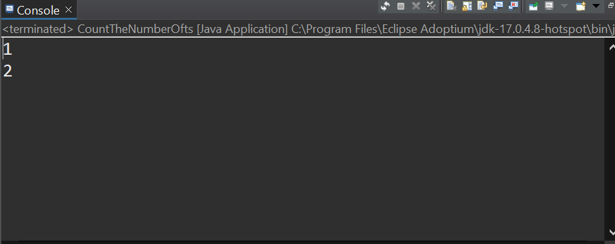

1. **Write a program to count no of words in a text file and average word size.**

package assignmentQ67;

import java.io.BufferedReader;

import java.io.FileReader;

public class Abc {

public static void main(String[] args) throws Exception {

String line;

int count = 0;

FileReader file = new FileReader("E:\\DAC KOCHI\\ABC\\cdac.txt");

BufferedReader br = new BufferedReader(file);

while ((line = br.readLine()) != null) {

String words[] = line.split(" ");

count = count + words.length;

}

System.***out***.println("Number of words present in given file: " + count);

br.close();

}

}

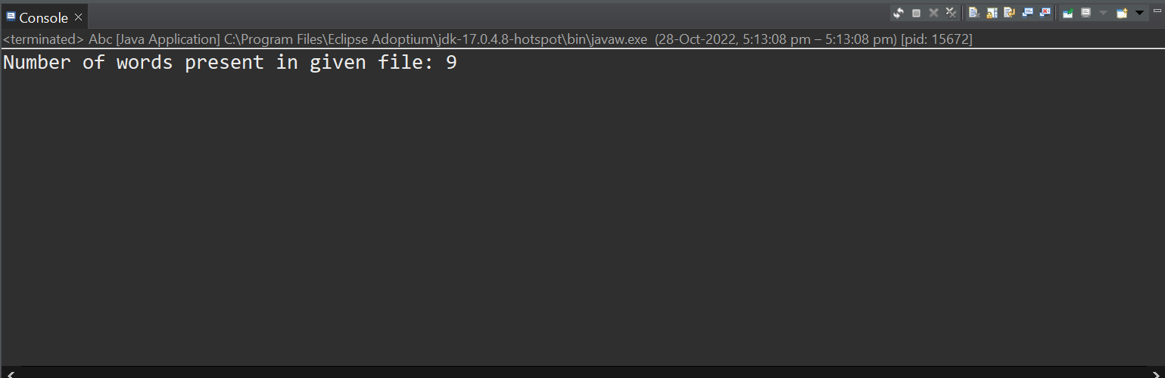

**3. Write a program to count number of bytes in a image file(jpeg/png/gif).  Also**

**find how much time it will take to upload the file on server if internet speed is**

**256 bps(bits per second).**

package assignmentQ68;

import java.io.File;

public class Ab {

public static void main(String[] args) {

File f = new File("E:\\DAC KOCHI\\ABC\\GYDF7407.JPG");

if (f.exists()) {

double bytes = f.length();

double megabytes = (f.length() / 1024 * 1024);

double speed = 256;

System.***out***.println("Total time that will take to upload the file on server : "

+ (int) (bytes / speed / 60) + " secs" + " ");

System.***out***.println(("Total Nos. of Bytes in a image file: " + bytes));

System.***out***.println(("Total Nos. of MegaBytes in a image file: " + megabytes));

} else

System.***out***.println("File doesn't exist");

}

}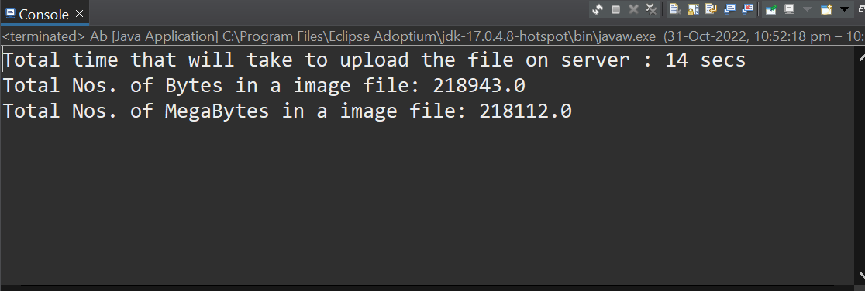

}

**4. Write a program to store your shopping details in a binary file(shopping.dat)**

**with information itemName, price, quantity. (Use ObjectOutputStream to store**

**Item class object).**

/*

Assignment Q4

Q69. Write a program to store your shopping details in a binary file(shopping.dat)

with information itemName, price, quantity. (Use ObjectOutputStream to store

Item class object).

*/

package assignmentQ69;

import java.io.FileNotFoundException;

import java.io.FileOutputStream;

import java.io.IOException;

import java.io.ObjectOutputStream;

import java.io.Serializable;

class Person implements Serializable {

String itemName;

int price;

int quantity;

public Person(String itemName, int price, int quantity) {

super();

this.itemName = itemName;

this.price = price;

this.quantity = quantity;

}

*@Override*

public String toString() {

return "[ItemName=" + itemName + ", Price=" + price + ", Quantity=" + quantity + "]";

}

}

public class Ab4 {

public static void main(String[] args) throws FileNotFoundException, IOException {

try (FileOutputStream fos = new FileOutputStream("E:\\DAC KOCHI\\ABC\\shopping.dat");

ObjectOutputStream oos = new ObjectOutputStream(fos)) {

Person f = new Person("Bag", 2000, 50);

oos.writeObject(f);

}

System.***out***.println("done");

}

}}

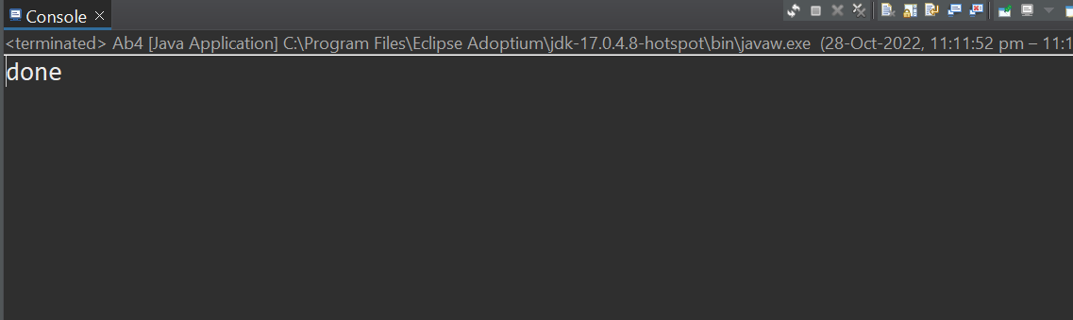

**5. Write a program to read data from shopping.dat file created in above problem**

**and find total money spent on all shopping items. . (Use ObjectInputStream to**

**read Item class object).**

package assignmentQ69;

import java.io.FileInputStream;

import java.io.FileNotFoundException;

import java.io.IOException;

import java.io.ObjectInputStream;

public class assignmentQ5 {

public static void main(String[] args) throws FileNotFoundException, IOException, ClassNotFoundException {

try (FileInputStream fis = new FileInputStream("E:\\DAC KOCHI\\ABC\\shopping.dat");

ObjectInputStream ois = new ObjectInputStream(fis)) {

Person p = (Person) ois.readObject();

System.***out***.println(p);

}

System.***out***.println("done");

}

}

